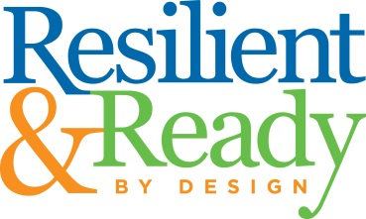

Resilient and Ready by Design Teacher Leader Institute Expectations:

- Attend the showing of “Resilience: The Biology of Stress and the Science of Hope” January 31, 2018

- Attend the Full Day RRD Institute on Wednesday February 28 @ Gateway

- Attend subsequent RRD Trainings in March, April and another Full Day Training in May (dates and locations TBD)

- Complete All Reading Assignments and Reflective questions. Reflective questions should be completed and sent electronically to Sally Skinner, sstown@icloud.com and Chris Perkins, cperkins@nkyec.org .

- Attend the “Excellence in Education” dinner scheduled for Wednesday, April 25, 2018.

- As a district team you will be required to develop an Implementation Plan and an All – Day Training for your district.

- As a team, present a segment of your “All Day” training at the May-Full Day RRD.

